MOVEMENT

EXAM STYLE QUESTIONS (CRITERION A)

- Classify the following quantities as scalars or vectors.
Temperature: Weight:
Mass: Time:
Velocity: Speed:
Displacement: Distance:
Acceleration Force:

- Use the number line below to give the positions of the objects (Don’t forget units!):
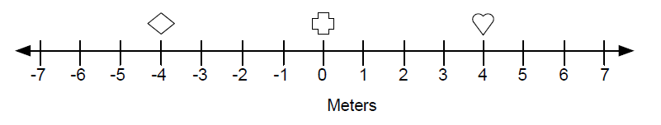
- What is the position of the heart? ……………………….
- What is the position of the diamond? ……………………….
- What is the position of the cross? ……………………….
3.
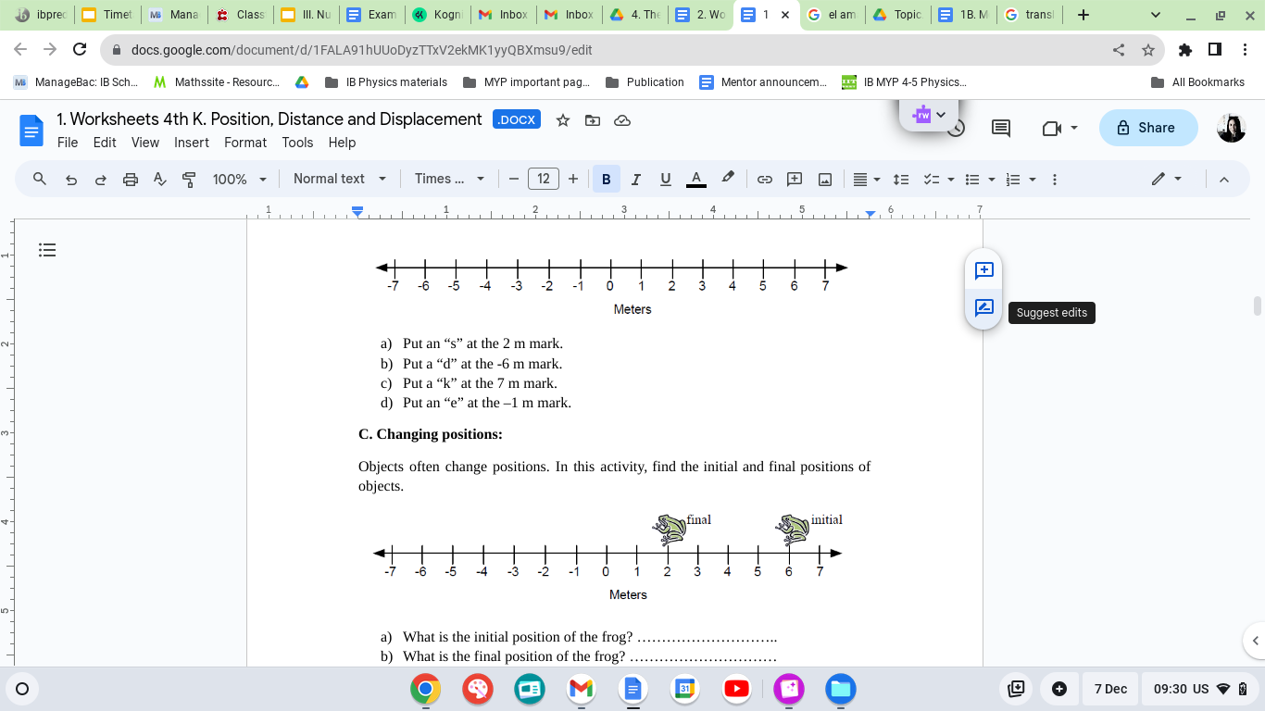
- What is the initial position of the frog? ………………………..
- What is the final position of the frog? …………………………
- If the frog traveled in a straight line from the initial position to the final position, what distance did it travel? …………………………….

4. Bessie the cow and Sally the bird both traveled from point “A” to point “B.” Sally traveled in a straight line and Bessie did not.
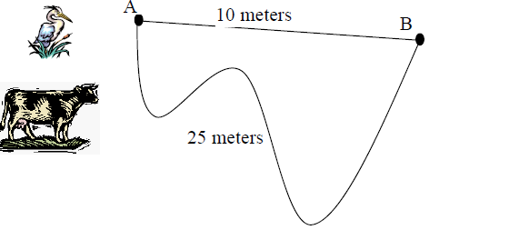
- What distance does Bessie the cow travel? ………………………….
- What distance does Sally the bird travel? ………………………….
- What is Bessie the cow’s displacement? ………………………….
- What is Sally the bird’s displacement? ………………………….

5.
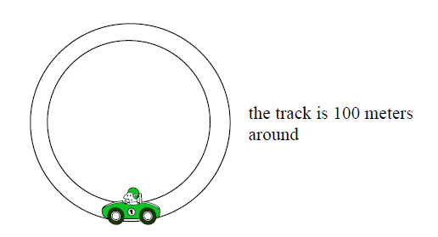
- If the car travels once around the racetrack, what distance does it travel? …………………………..
- If the car travels twice around the racetrack, what distance does it travel? …………………………..
- If the car travels once around the racetrack, what is its displacement? …………………………..

6.
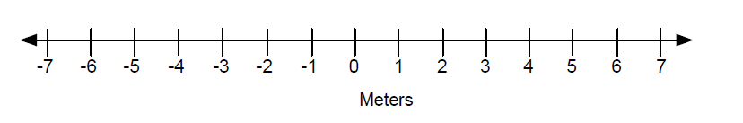
Use the above number line to help answer the following question:
Freddy the cat started at the –3 m position. He then walked to other locations. Mark each new location with the letter for that part.
- Freddy started at the –3 m position. (mark this position with an “a”)
- First, Freddy walked 2 meters in the positive direction (right) to the –1 m position.
- Second, Freddy walked 5 meters in the positive direction to the +4 m position.
- Third, Freddy walked 1 meter in the negative direction to the +3 m position.
- Finally, Freddy walked 8 meters in the negative direction to the –5 m position.
- Draw a displacement arrow that starts at Freddy’s initial position (-3 m) and ends at Freddy’s final position (-5 m).
- What was Freddy’s total displacement? (for this, you only need to look at his initial and final position) (be sure to include sign, number, and units)
- To get the distance Freddy traveled, add up all the distances:
2m + 5m + 1m + 8m = ______________ meters
- Is Freddy’s total displacement equal in size to Freddy’s total distance traveled?

7. A car is driving on a highway at $25\frac{m}{s}$.
(a) What is the car’s speed in $\frac{km}{h}?$
(b) How far does the car travel in 5 minutes? Express your answer in meters and kilometers.

8. (a) Polar bears are extremely good swimmers and can travel as long as 10 hours without resting. If a polar bear swims with an average speed of $2.6\frac{m}{s}$How far does it travel in 10 hours?
(b) Suppose the polar bears were running on land instead of swimming. If the polar bear runs at an average speed of $8.3\frac{m}{s}$ .How far does it travel in 10 hours?
9. A skier moves from location A to location B, C and D.
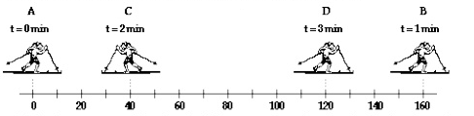
(a) Find the distance covered by the skier?
(b) Find the displacement of the skier?
(c) Calculate the average speed for the entire motion.
(d) Calculate the average velocity for the entire motion.

